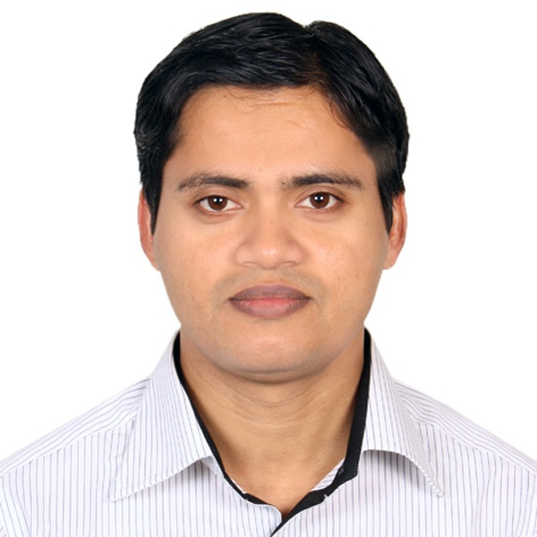
RESUME
of
MD. NAJBIR HOSSAIN

Mailing Address :
Bhuiya House#258/1 5th Flour,
Block# B, Nimaikesari Road
Word no-3, Sanarpar, Shiddirgonj,
Narayngonj.
Contact No: 8801722219418, 8801917049030
E-mail : najbir_01jan@yahoo.com
Or, najbirh@yahoo.com

- Career Objective

To work in an environment where there is an opportunity of being useful by means of self assessment and self improvement in both individual and group based work that will ultimately lead the future development of the organization.

- Scholastic Profile:

2009 M. Sc. (Fisheries)
2nd Class
Chandpur College,Chandpur
National University
2005 B. Sc (Zoology)
2nd Class
Chandpur College,Chandpur
National University
2003 H. S. C
Science
GPA- 2.20
Puran Bazar Degree College, Chandpur
Comilla Board
2001 S. S. C
Science
GPA- 2.63
Y.A.M. High School Chandpur
Comilla Board

- Language Proficiency

Good Command on Bangle & English Writing, Reading, Speaking.

Page 1 of 3

- Computer Literacy

Institution : Spectrum Computers
( Hardware & Software Training Institute)
64, Madartek Chowrasta, Sabujbag, Dhaka-1214.
Operating Systems: : Windows XP / 2007 / 2008
Internet Skills: : Having knowledge about Internet Browsing
E-mail Handling
Skills on Application Software:
MS office 2003 /2007/ 2010
(MS Word, MS Excel, MS Power Point, MS Access with typing speed of Bengali 20 W.P.M & English 25 W.P.M)
Adobe Photoshop, Illustrator
Capable to operate most of the application software’s.

- Professional Experience

- Senior Jequard Programmer( Logica & Hqpds.) at Ningbo Cixing, Company Ltd.
From 12 February 2012 to 17-06 2013 & 01-10-2013 to 28-02-2015.
- Trainee Product Marketing officer, AMEX Card, Cards Division. The City Bank Ltd. From- 23-06-2013 to 31-09-2013.
- Chif Jequard Programmer (Shima seiki & Logica Cks, Hqpds) at Kores
Bangladesh Sweater Factory , From- 01-03-2015 to March 2017.
- Manager programmer & Marketing, Hillock Fashion, (Tongi, Turag).
Job Description- Make the Sweeter Design by using Computer Software. To flow the production, select skill manpower and communicate the merchandiser and Buyer to complete the work smoothly .

Page 2 of 3

- Personal Profile:

Father's Name : Md. Kabir Uddin Faruki
Mother's Name : Mhamuda Akter

Date of Birth : 1st January 1986
Marital Status : Married
Gender : Male
Nationality : Bangladeshi by birth
Religion : Islam
Height : 5' – 1"
Weight : 67 KG
Recreation : Reading, Music, Internet Browsing, Traveling etc.
Permanent Address : Vill:Bhakhorpur, Post: Bhakhorpur,
P.S. Chandpur, Dist:Chandpur
Hobby : Reading Newspaper, Religious books, Making friendship

- References:

To be provided upon request
- Saiful Alam
Editor In charge, The Daily Jugantor Newspaper.
Beside the Jamuna Future Park.
Mob: 01711594159
Relation- Cousin
- Nesar Ahmed Bhuiyan
Principal Officer
Export Import Bank Bangladesh Ltd.
Regional Office, Paduar Bazar, Bissow Road, Comilla
Mob: 01712070718

- Declaration:

I do hereby declare that the above information is true and correct to the best of my knowledge.

_________________
(Md. Najbir Hossain)
Date:
Page 3 of 3

